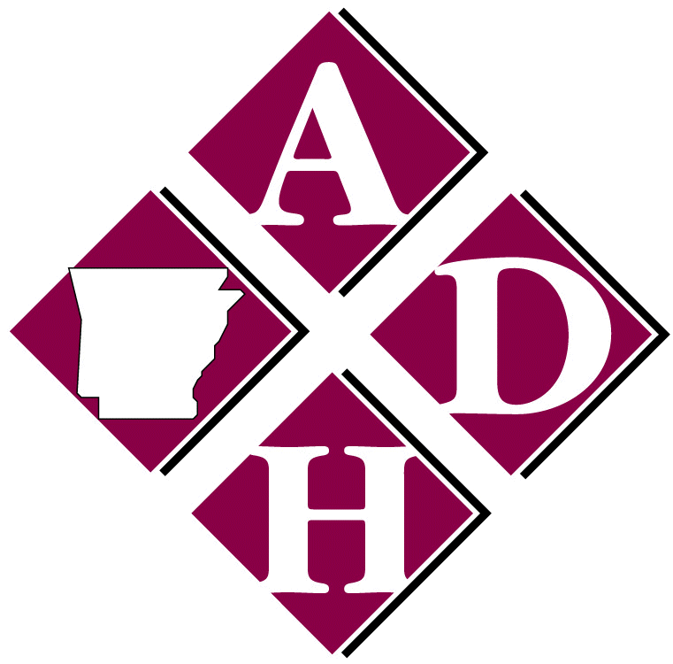

Arkansas Department of Health

4815 West Markham Street ● Little Rock, Arkansas 72205-3867 ● Telephone (501) 661-2000
Governor Asa Hutchinson
Nathaniel Smith, MD, MPH, Director and State Health Officer

Guide for School Nurses to Report Communicable Diseases
- If a parent/guardian calls and reports that their child has varicella, pertussis, meningitis, or any other communicable disease, please find out where/who diagnosed the child and then report to Arkansas Department of Health (ADH) using the Communicable Disease Reporting Form. Once ADH receives the report and confirms the diagnosis, a health department nurse might contact you to collect more information about the child.

- When ADH contacts the school, we might need some of the following information to facilitate identification and prevention methods for the disease under surveillance:
- Teacher’s name and class/classes attended by case, the number of students in class, and the seating arrangement of class (tables versus chairs in rows). *electronic copy of class rosters are very helpful
- If student is a bus rider, we will need the bus number, whether they have assigned seating on bus, does the bus go to multiple schools, and length of ride.
- Once we identify those at risk we may need to determine how close the child sits to each contact (example- with pertussis we treat based on proximity to case).
- Immunizations status of those in class, bus ,etc. that we identify as a contact
- If there are any immunization exemptions in the school, we need to know if they are a contact to the case, what type of exemption they have, and if they have had any immunizations previously. The ADH Communicable Disease Medical Director will provide guidance on who should be excluded and length of time for exclusion.
- Once we have collected the information and reviewed with our medical director, we will make a recommendation to the school. If applicable, ADH will provide the school with a letter for parents along with instructions and a fact sheet about the disease.

- Please confirm the recommendations and appropriate follow up actions with the health department. The school can choose to go above and beyond the health department’s recommendations. ADH may provide a letter/fact sheet for parents. There are several different kinds of letters that may be used.
Close Contact Letter- used for students that have been identified as a close contact to the case and it explains that the child/student has been named as a close contact and needs treatment/vaccination and advises them what to do.
Minimal Contact Letter- used for students that have had minimal contact with the case but need to be aware of what signs and symptoms routinely occur and what to do.
Fact Sheet- Information sheet for parent/guardian that explains the disease, how it is spread and what signs and symptoms routinely occur.

- If an outbreak is identified, ADH will need your help in collecting information on the students, assessing immunization status, and distributing information to parents in a timely manner.

For any questions please contact your local Communicable Disease Nurse Specialist (CDNS) or you may call our division of Communicable Disease at 501-537-8969.

